WEEK 2 TASK REPORT/LOGBOOK

Student Name: Precious Jaiyesimi Eniola
Admission number: BIT/2024/39050
Course: Mobile Application Development

TOOLS AND TECHNOLOGIES USED
- Flutter (Dart language)
- Visual Studio Code
- Android Emulator / Chrome
- SharedPreferences (Local Storage)
- HTTP package (API Integration) and JSON Placeholder API

Demonstrations
Figure 1: File Structure in Vs Figure 2: Splash Screen
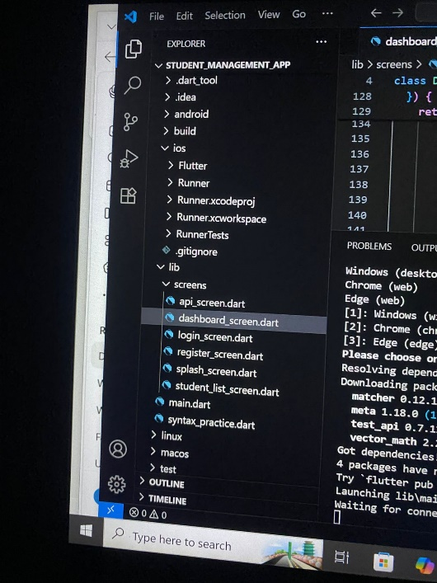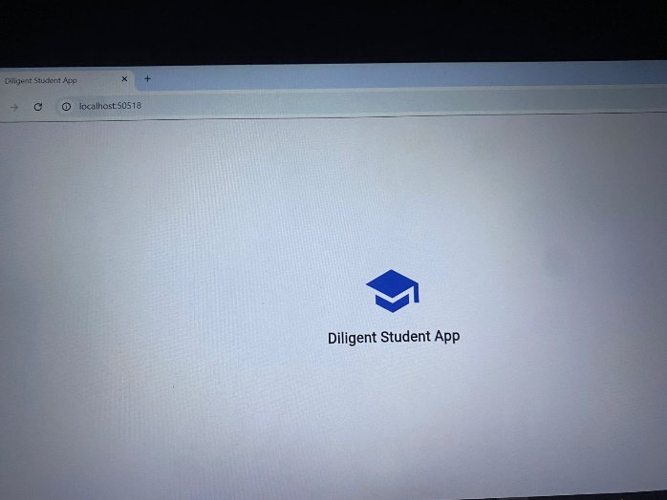

Figure 3: Login Screen
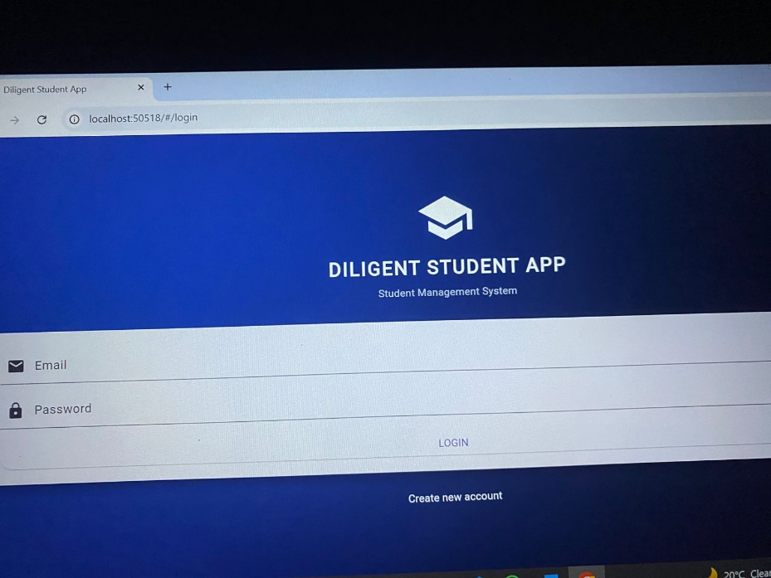

Figure 4: Registration Screen
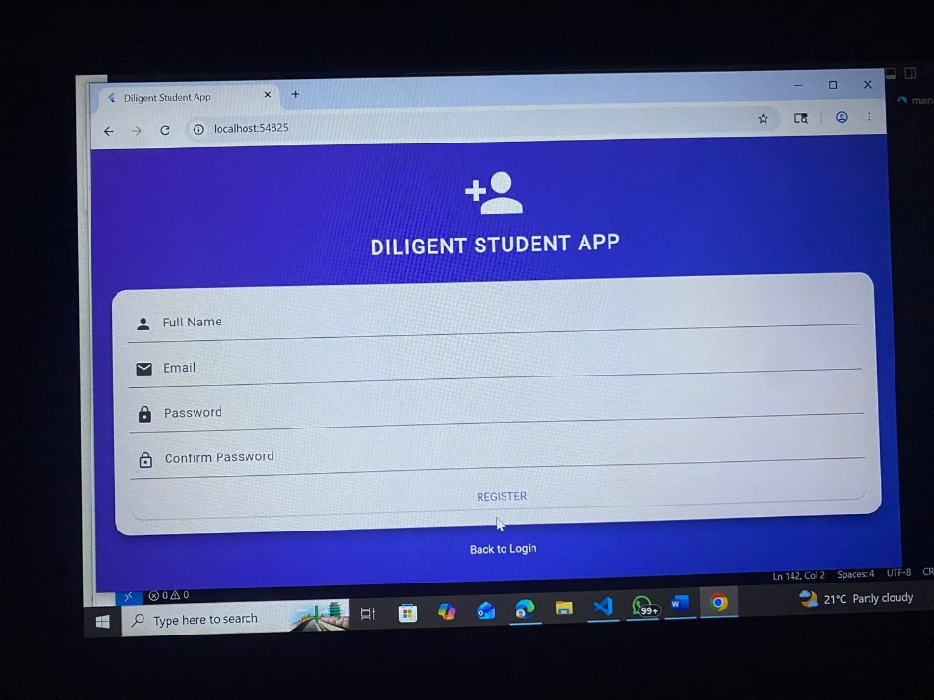

Figure 5: Student List Screen
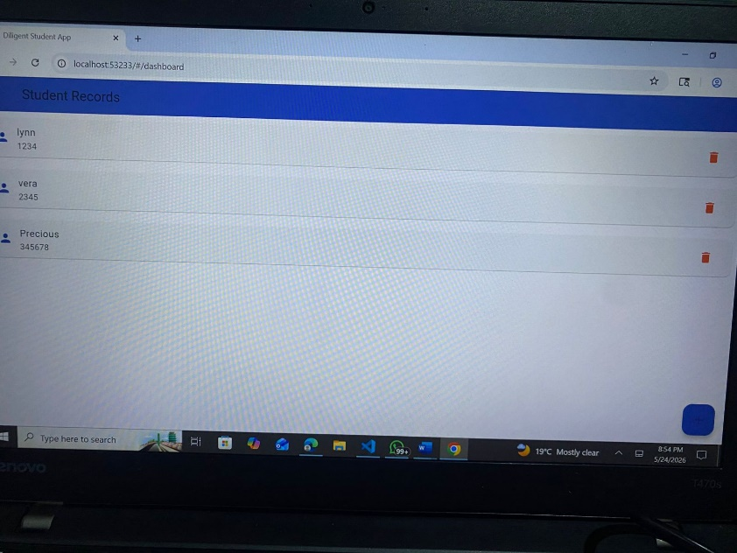
Figure 6: Dashboard Screen
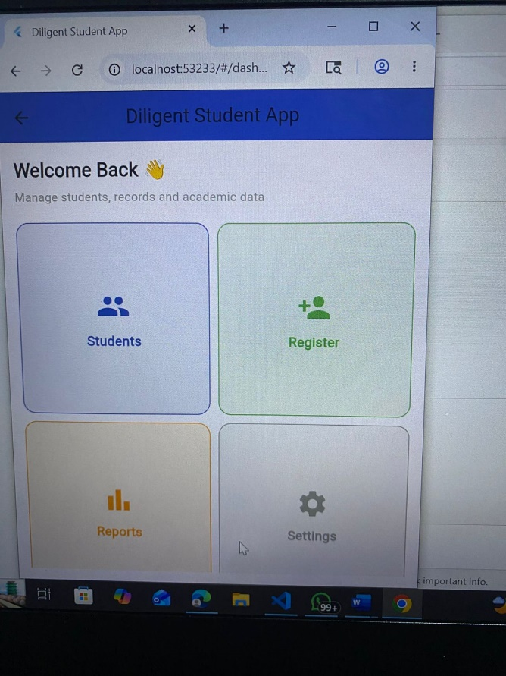

Figure 7: API Integration Screen
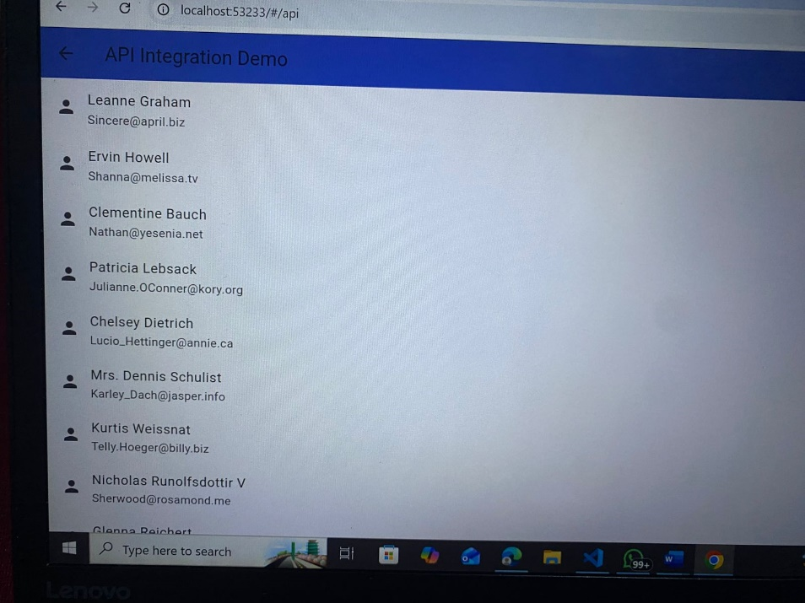

Developing the Diligent App helped me improve my understanding of Flutter widgets, navigation, and user interface design. I learned how to organize screens and create a more interactive mobile application. During the development process, I encountered challenges with layout arrangement and navigation, but I was able to overcome them through practice and research. This project increased my confidence in mobile app development and strengthened my problem-solving skills.

